SAN MATEO COUNTY LAW LIBRARY
RESEARCH GUIDE #8
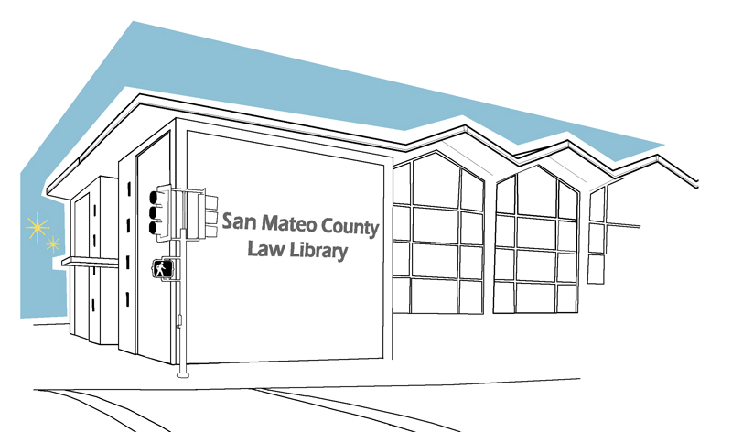

HOW TO RESCHEDULE A HEARING OR TRIAL: MOTION TO CONTINUE
This resource guide only provides guidance, and does not constitute legal advice. If you need legal advice you need to speak with an attorney. To find an attorney to assist you, you may contact the San Mateo County Lawyer Referral Service at (650) 369-4149.

WHAT IS A MOTION TO CONTINUE?
A Motion to Continue is a request by one or both parties in a legal dispute to the Court to extend or reschedule a hearing or trial date to a specified new date.
WHY MUST I NEED ONE?
If you have good cause to delay a hearing or trial, you must file a Motion to Continue with the Court.
Please note, under the Trial Court Delay Reducation Act, Courts are required to ensure the prompt disposition of civil cases. Therefore, granting a Motion to Continue are generally disfavored by courts.
The following are potentially good cause for a trial continuance:
- Unavailability of an essential witness;
- Unavailability of another party due to death or other excusable circumstance;
- Unavailability of trial counsel because of death, illness, or other excusable circumstance; and/or
- Substitution of trial counsel where there is an “affirmative showing that the substitution is required in the interests of justice.”

To read a more complete list of good cause justifications, please see: CRC 3.1332 (b)

HOW DO I FILE A MOTION TO CONTINUE?
Step 1: Take action ASAP
File your motion as soon as possible! The continuance motion must be made “as soon as reasonable practical once the necessity for the continuance is discovered.” [CRC 3.1332 (b)]
Step 2: Create the Motion, a Memorandum of Points and Authorities, and a Decaralation
Given the unique nature of each situation, there is no standardized form. Rather, you must create a Motion to Continue yourself.
In addition to the motion itself, you must also create Memorandum of Points and Authorities that is attached to the Motion itself. The Memorandum of Points and Authorities sets forth the background of your case as well as the legal argument of why there is good cause for the Court to grant your Motion.
Finally, you must also create a Declaration that sets forth the facts as to why you must postpoine an upcoming hearing or trial.
Again, there are no standardized forms. There are, however, many samples and templates that can help you. Here are two sources:
- Chapter 136 of the ‘California Forms of Pleading and Practice’ discusses Motions to Continue in depth and offers several templates, including a Declaration.
- A SAMPLE Motion To Continue, Memorandum of Points and Authorities, and a Declaration are attached. It was completed by a hypothetical "Kent Lunar," who is asking to continue his trial so he has the opportunity to find a new attorney. THIS IS ONLY AN EXAMPLE. You will need to modify the text extensively so that it makes sense and is relevant to your unique case.
Please note you must print your motion single-sided on 28-line pleading paper; the court will not accept double-sided documents, or documents not on pleading paper.
Step 3: Make Copies
Make a copies of your motion. Make one for yourself, your lawyer, other part(ies), and their lawyer (if they have one), as well as for the Court.
Step 4: Have the Motion served on the other party(ies)
You must serve your motion on the other parties to the action so that they are aware of your effort to delay the hearing or trial. A person over the age of 18 who is not a party to the case must personally deliver or mail a copy of the Motion along with a copy of the unsigned proof of service form on other parties to the action. The unsigned proof of service form can be attached as the last page of the Motion.
The person who is serving your motion must complete Judicial Council Form POS-020: Proof of Personal Service – Civil or a POS-030: Proof of Service by First Class Mail.
The proof of service form should be completely filled out before being filed with the clerk. Make a copy for your own record.
Step 5: File your Motion and Proof of Service with the Court

File your motion and Proof of Service at the San Mateo County Hall of Justice, Room A at 400 County Center, Redwood City, CA. Please note that office hours are Monday - Thursday, 8:30 a.m. to 2:00 p.m.There is a drop box for after hours civil filings located outside of the Clerk's Office Room A on the first floor.

KENT LUNAR
1234 ABC ST.
SAN MATEO, CA, 94401
650-555-5555

Defendant, In Pro Per

SUPERIOR COURT OF CALIFORNIA
COUNTY OF SAN MATEO

HENRY ROSHE,  Plaintiff,  vs.  KENT LUNAR,  Defendant | )  )  )  )  )  )  )  )  )  )  )  )  )  )  )  )  )  ) | Case No.: 34-2009-00000001  NOTICE OF MOTION AND MOTION TO CONTINUE TRIAL; POINTS AND AUTHORITIES; DECLARATION OF  KENT LUNAR
To plaintiff, HENRY ROSHE, and to his attorney(s) of record:

NOTICE IS HEREBY GIVEN that on April 15, 2013 at 8:00 a.m., or as soon thereafter as the matter may be heard, in Department XX of this court, located at 400 County Center, Redwood City, CA, 94063, defendant, KENT LUNAR, will, and hereby does, move for an order continuing the trial, heretofore set for June 4, 2013, reopening discovery until 30 days prior to the new trial date, and referring this matter back to the case management program for trial setting. The motion will be made on the grounds that the defendant’s attorney has been unavailable due to death, and substantial discovery remains to be completed, and the defendant is unable to adequately prepare this case for trial either through new counsel or as a self-represented litigant in the time remaining.

The motion will be based on this notice of motion, on the declaration(s) of KENT LUNAR, and the supporting memorandum served and filed herewith, on the records and file herein, and on such evidence as may be presented at the hearing of the motion..

Dated: March 13, 2013 By:_____________________________________
KENT LUNAR
Defendant, In Pro Per

Memorandum of Points and Authorities in Support of Motion to Continue

I. BACKGROUND
This lawsuit arises from $20,000 that was loaned by the plaintiff to a defendant. The plaintiff is suing the defendant in order to recover moneys loaned. The defendant was initially represented by counsel; however counsel is now unavailable due to death on February 14, 2013.
Defendant, has been seeking replacement counsel diligently during this last month, and has not been able to find an attorney who is both willing to handle his case, and able to prepare the case for trial by the current trial date set. Additionally, discovery remains to be completed in this lawsuit. This is the first request for continuance made by the defendant.

II. LEGAL ARGUMENT
GOOD CAUSE EXISTS FOR CONTINUANCE IN THAT DEFENDANT’S COUNSEL IS UNAVAILABLE DUE TO DEATH. DEFENDANT IS SEEKING NEW COUNSEL, AND SUCH NEW COUNSEL WILL BE UNABLE TO ADEQUATELY PROSECUTE THIS MATTER AT TRIAL WITHOUT A CONTINUANCE.

A. Good Cause. A court may grant a continuance before or during trial on an affirmative showing of good cause and each request for a continuance must be considered on its own merits (Cal. Rules of Ct., Rule 3.1332(c)).

B. Significant, Unanticipated Change in Case Status Constitutes Good Cause for Continuance. The circumstances that may indicate good cause for a continuance include a significant, unanticipated change in the status of the case as a result of which the case is not ready for trial ( Cal. Rules of Ct., Rule 3.1332(c)(7)). Counsel originally represented the defendant. Unfortunately, as the case progressed, counsel has got into a car accident, and died instantly on February 14, 2013.

C. Continuance Sought as Soon as Reasonably Practical. A party seeking a continuance of the date set for trial, whether contested or uncontested or stipulated to by the parties, must make the motion or application as soon as reasonably practical once the necessity for the continuance is discovered (Cal. Rules of Ct., Rule 3.1332(b)).

The defendant has been diligently seeking replacement counsel during the last month; however, the process has been hampered by a combination of factors. The attorneys the defendant has been able to reach are either too busy, on vacation, do not handle this type of case, or are priced outside of the defendant’s ability to pay. Because of these reasons, he has been unable to find a replacement attorney. Additionally, at this point, were the defendant to find an attorney willing to take his case, he has been informed that it is extremely unlikely that any attorney would be able to have this case prepared for trial by the current mandatory settlement conference and trial date.

Furthermore, the defendant, upon reviewing the records sent to him by his former attorney, believes additional discovery is necessary to properly present this case for trial.

D. Opportunity for Full Presentation. A continuance should be granted if failure to allow the continuance would probably or possibly prejudice the party seeking the continuance by depriving that party of the opportunity to fully and fairly present his/her/its case (Cadle Co. v. WorldWide Hospitality Furniture (2006) 144 Cal. App. 4th 504, 513–515, 50 Cal. Rptr. 3d 480; In re Dolly A. (1986) 177 Cal. App. 3d 195, 199, 201, 222 Cal. Rptr. 741; Cohen v. Herbert (1960) 186 Cal. App. 2d 488, 494, 8 Cal. Rptr. 922).

Dated: March 13, 2013 By:_____________________________________
KENT LUNAR
Defendant, In Pro Per
DECLARATION OF KENT LUNAR

I, KENT LUNAR, am the Defendant in this matter, and I declare the following in support of my motion for continuance:
- Until February 14, 2013, I was represented by counsel in this case.
- My counsel is now unavailable due to death
- I have never been a plaintiff or defendant in a lawsuit before, and am in the process of finding replacement counsel.
- If I am unable to find a replacement attorney, I will need to prepare to represent myself.
- During the last month, I have contacted numerous attorneys’ offices, and have to date found no attorney that is both willing and able to handle my lawsuit.
- Additionally, after reviewing my former attorney’s file for this case, there appears to be a substantial amount of discovery that will be necessary to bring this case to trial, as the financial records of the plaintiff(s) are expected to be critical in proving the money loaned by the plaintiff, and the intent of the parties.
- It will be at least several more months until this matter may be prepared for trial, and the timing will depend on how quickly I am able to find a replacement attorney, or else prepare to represent myself. For this reason, I ask that the existing trial date and case settlement conference be vacated, my case be referred back to the Case Management Program for setting of a trial date, and that discovery remain open until 30 days before the next trial date that is set.

I declare under penalty of perjury under the laws of the State of California that the foregoing is true and correct.

Dated: March 13, 2013 By:_____________________________________
KENT LUNAR
Defendant, In Pro Per

