SAN MATEO COUNTY LAW LIBRARY
RESEARCH GUIDE #3
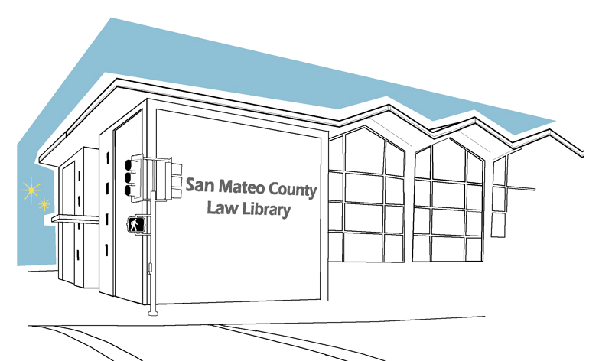

SMALL CLAIMS FILING PROCEDURE
This resource guide only provides guidance, and does not constitute legal advice. If you need legal advice you need to speak with an attorney. To find an attorney to assist you, you may contact the San Mateo County Lawyer Referral Service at (650) 369-4149.
San Mateo Superior Court has information about Small Claims available on their website at www.sanmateocourt.org. In their small claims section, you can learn about how to talk to an attorney for free, watch an instructional video about the small claims process, and get additional information about how to file your papers. You can also call the Court’s small claims informational phone system at 650-363-4303 (the information is available in English and Spanish).

DETERMINING WHETHER YOU ARE ELIGIBLE TO FILE A CLAIM IN SMALL CLAIMS COURT

Generally, an individual may not ask for more than $10,000. Businesses and other entities (e.g., corporations, partnerships, limited liability companies, etc.) may not ask for more than $5,000. This limit on businesses does not apply to sole proprietorships. You can file as many claims as you like in small claims court up to $2,500. But you can only file two claims in small claims court in a calendar year that asks for more than $2,500.

Below are exceptions to the general restrictions:
- If you are filing a claim for bodily injuries because of a car accident against an individual who has car insurance that includes a “duty to defend”, you can only sue the individual for $7,500.
- As a natural person, you can sue a guarantor for up to $6,500 or $2,500 if they do not charge for the guarantee. A "guarantor" is a person or company that promises to be responsible for what another person owes. If you are an entity other than a natural person and the guarantor charges for its services, you can sue for up to $4,000. However, you can sue the Registrar of the Contractors State License Board as a guarantor for up to $10,000.
- Collection agencies cannot sue in small claims court for debts assigned to them, and neither can individuals who have been assigned the rights to a claim or contract.
Common types of small court claims:
- Property damage or personal injury from a car accident
- Landlord/Tenant security deposits
- Disputes with contractors about repairs and home improvement jobs
- Collection of money owed
- Some Homeowner’s Association disputes

If you are being sued and are not filing a Defendant’s Claim, you do not have to file a formal answer. You only need to prepare your defense orally (and support it by witnesses and documentary evidence) and attend the scheduled trial. You must go to court if you want your side of the case to be considered. If you do not go to court, a judgment may be entered against you. This would be a judgment based on the evidence that the side suing you provided, without you having a chance to provide any evidence of your own.

HOW DO I FILE A CLAIM IN SMALL CLAIMS COURT?

STEP 1: Obtain and Complete Court Forms

To file a claim, you must complete the necessary court forms. These forms tell the court and the person or business you want to sue about your claim.

- (Form SC-100) - Plaintiff's Claim and ORDER to Go to Small Claims Court.
  - This form is the claim and must be completed to begin a claim in small claims court.
- (Form SC-100A) – Other Plaintiffs or Defendants (Attachment to Plaintiff’s Claim and ORDER to Go to Small Claims Court).
  - Only complete this form if there are more than 2 defendants or 2 plaintiffs.
- (Form MC-030) – Declaration.
  - Only complete this form if you need more space to describe your claim and what happened or you need witness statements.
- (Form SC-103) - Fictitious Business Name (Small Claims).
  - You may need to complete this form if you are a business.

If you need assistance, you can attend a workshop at the court and speak to the Small Claims Legal Advisor for 10 minutes for free. Information about this service is located online at
www.sanmateocourt.org/documents/forms_and_filing/sc-5.pdf

You can also go to a public law library (http://www.publiclawlibrary.org/) or a public library (in San Mateo County go to http://plsinfo.org/) and ask a librarian for self-help books to help you complete your forms.

When filing a claim in small claims court, the exact name of the defendant must be used. Follow the guide below to find out how to name a defendant:

- Suing a person
Write first name and last name, middle initial if known. If other names have been used, type first name and last name and use “aka” then list the other names that have been used.
- Suing both husband and wife
Write full names of both the husband and the wife.
- Suing Domestic partners
Write full names of both domestic partners.
- Suing a business owned by one person
Write the owner’s name and the business’ name. Check county records for fictitious name filing for the business to see exactly how the owner’s name appears and make sure the correct name of the individual owner is used.
- Suing a partnership
Write the name of the partnership and the names of the partners individually.
- Suing a Corporation or a Limited Liability Company
Write the exact name of the corporation. Be sure to check the Secretary of State’s website to find the agent for service of process, as this is the person chosen by the business or corporation to receive legal documents. Write the agent’s name, along with that of the company.
- Suing a business owned by a corporation
Write the name of the corporation and the name of the business. (Corporation doing business as “name of business”) Be sure to check the Secretary of State’s website, find the agent for service of process, as this is the person chosen by the business or corporation to receive legal documents. Write the agent’s name, along with that of the company.
- Suing because of a car accident
Write the name of the driver and the owners of the car. If there were multiple cars involved, it is important to name each driver and owner. (Ex. Sam Jones, Driver, and John Smith, Owner). If you do not know the name of the owner of the car but you have the car's license plate number, you can complete form INF 70 - Request for Record Information to the DMV to get the name of the registered owner.

STEP 3: Ask for Payment

Small claims cases require that you ask the other side for payment before you go to court (unless there is a good reason why you cannot). You can ask in person, by phone, or in writing. You will have to tell the court that a demand for payment was made and how the demand was made. If you decide to ask for payment in writing, you can use a demand letter. Bring a copy of it to your court hearing to show the judge.

STEP 4: File your claim

To file your claim, you must:

- Figure out how much you have to pay to file
You will have to pay a fee to file papers with the court. Filing fees vary depending on the amount of the claim and how many times you have filed a claim in small claims court in the past 12 months. Check the fee schedule.

- Take your forms to your small claims clerk
Take your (Form SC-100) Plaintiff's Claim and ORDER to Go to Small Claims Court and any other forms that you may have needed to complete in Step 1 to the court clerk.

- File your forms with the clerk and receive a court date
When you take your forms to the court, the clerk will look at your forms and may ask you a few questions. If you want your hearing to be at night, ask the clerk for possible evenings and times. After looking at your forms, the clerk will usually stamp the forms "Filed" and fill in the date, time, and location of your court hearing. The clerk will keep the originals of the forms and give you a copy for yourself and other copies for each defendant you are suing.

If you do not speak English well, bring someone to interpret for you. Do not ask a child or a witness to interpret for you. Get tips to help you work with a court interpreter.

If you are deaf or hard-of-hearing or have a disability, ask for an interpreter for other accommodations. Get more information for persons with disabilities and a form to ask for an accommodation.

STEP 5: Serve your claim

"Service" is when someone NOT you OR anyone else listed in the case, gives a copy of your court papers to the person, business, or public entity, you are suing. Service lets the other side know: what you are asking for; when and where the trial will be; and what they can do.

(Form SC-104) Proof of Service must be completed after service. Below are two documents that will help you understand “service” and “proof of service”. If you have any questions after reading these two documents, visit the small claims legal advisor.

- (Form SC-104B) (Small Claims) What is Proof of Service?
- (Form SC-104C) (Small Claims) How to Serve a Business or Public Entity

Step 6: Go to Court

After you file your court forms, you will receive a hearing date. You must go to court. You may not send anyone else to represent you in small claims court, unless given permission ahead of time by the court, following the filing of a written request. You may never have a lawyer represent you at a Small Claims hearing (except for Appeals).

Bring any papers that support your claim and bring two or more copies of each document. This is called "evidence”. Evidence can be:

  - Contracts
  - Estimates (take at least 2)
  - Bills
  - Photographs
  - Diagrams that show how an accident happened
  - Police reports

If you need papers that someone else has, complete (Form SC-107) a Small Claims Subpoena for Personal Appearance and Production of Documents at Trial or Hearing and Declaration and request the documents that you need. Learn more about subpoenas.

Bring copies of all your court papers and your Proof of Service.

Bring people to support your claim. (witnesses)
Bring witnesses who saw what happened or who are experts on that subject. For example, a neighbor who saw the accident or a mechanic who looked at your car. Do not bring people unless you know they will support you. Witnesses who are not friends or relatives may be more effective in proving your case. But sometimes the only witnesses are your friends and relatives. They should testify and present themselves in a professional manner and be objective and not emotional.

(Form SC-107) – A Small Claims Subpoena must be completed if you need a witness who will not go to your hearing voluntarily to go to your hearing.

Alternatively, you may present the testimony of witnesses by having them sign a written statement under oath. This is called a Declaration. Bring those Declarations to your hearing, and submit them to the judge or commissioner.

