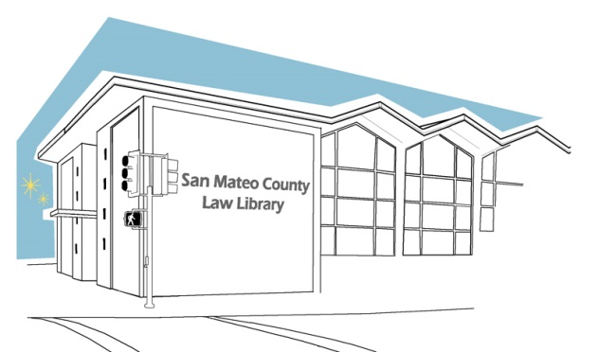
SAN MATEO COUNTY LAW LIBRARY
RESEARCH GUIDE #2

EXPUNGING YOUR RECORD

This resource guide only provides guidance, and does not constitute legal advice. If you need legal advice you need to speak with an attorney. To find an attorney to assist you, you may contact the San Mateo County Lawyer Referral Service at (650) 369-4149.

WHAT IS AN EXPUNGEMENT?
Expungement is a method for clearing up your criminal record. This procedure reopens your criminal case, dismisses the conviction, and re-closes the case without a conviction.

WHAT TO DO:
NOTE: These instructions (Video Tutorial available here) are for the most common cases, if you have a unique situation, we advise you to talk with an attorney.
STEP 1: Determine if You Are Eligible for an Expungement

To be eligible to expunge your conviction, you must meet all the following conditions:
- Your conviction must meet the guidelines described in PC § 1203.4, PC § 1203.4a, PC §1203.41, PC § 17, or PC § 1203.49.
- At least one year must have passed since your conviction.
- You must have completed the terms of your sentence.
- You cannot be serving a sentence for any offense, or be charged with the commission of any other offense.
- Your probation for the conviction you’re trying to expunge must not have been revoked, and not reinstated.
- Deferred Entry of Judgment PC § 1203.43, Petitioner performed satisfactorily during the period in which deferred entry of judgement was granted and the criminal charges were dismissed under PC § 1000.3.
- If you have a felony, to learn more about it, look under “Figuring Out Your Options” on this page: http://www.courts.ca.gov/1070.htm

STEP 2: Obtain a Copy of Your Criminal Record (or Case Summary)
You will need a copy of your criminal record or case summary for each conviction you wish to expunge.
For a copy of your state-wide criminal record, visit a Live Scan fingerprinting site. To find a Live Scan site near you, see https://oag.ca.gov/fingerprints/locations.
After providing your fingerprints and paying the required fee, a copy of your criminal record will be mailed to you.
More information about requesting your statewide criminal history is available at https://oag.ca.gov/fingerprints/record-review

STEP 3: Complete the Required Forms
First, you need to learn how to read your criminal record or case summary. See the sample at the end of this guide.
The Judicial Council forms used in this procedure are:
- Petition for Dismissal (CR-180)
When filling out this form, you need to write down ONLY the cases you were convicted for. If there is more than one conviction under a different case number, you need to fill out a separate CR-180 for each one of these different case numbers. See the sample at the end of this guide.
- Order for Dismissal (CR -181)
When filling out this form, just complete it with your personal information at the top of the 2 pages and leave the rest blank. The judge will review this form after reviewing your petition. See the sample at the end of this guide.
- Attached Declaration (MC-31) (IGNORE if not provided with the packet.)
When filling out this form, you are basically attaching a declaration stating why you want the expungement and explaining your situation in life. In this declaration, you may want to discuss:

• Your plans for the future;
• The reasons you offended, and how your life is different today than it was when you offended;
• How the conviction has hurt your employment chances;
• If you have received any training or education since your conviction;
• Any occurrence in your life that changed how you interact with your community; and
• Any 12-step or religious affiliations you have.
See the sample at the end of this guide.
- Proof of ServicePOS-020 or POS-040
When filling out one of these forms, write your personal information at the top of the page, list the forms you are attaching, and the information of the party (the District Attorney) to whom a person of your choice (it can be a relative, a friend, or a registered California process server) is serving this document. See the sample at the end of this guide.

STEP 4: FILE YOUR FORMS
Expungement forms are filed in the county where you were convicted. For the San Mateo County, these are filed at the Hall of Justice located at 400 County Center Redwood City, CA 94063 on the 4th Floor.
There is a fee for processing your Petition. For the San Mateo County the fee is $60. Fee waivers are available for low-income petitioners.

AND, THAT SHOULD BE IT!
For most people, no court hearing will be scheduled. Instead, the petition is automatically granted as long as you have met all the requirements. Keep in mind that the turnaround for expungement is from 30 to 90 days.
After some time, you should receive a letter in the mail letting you know that your record has been expunged. If you are denied, don’t worry, there is no limit to the number of times you can apply for expungement. You might have just caught the wrong person on the wrong day.
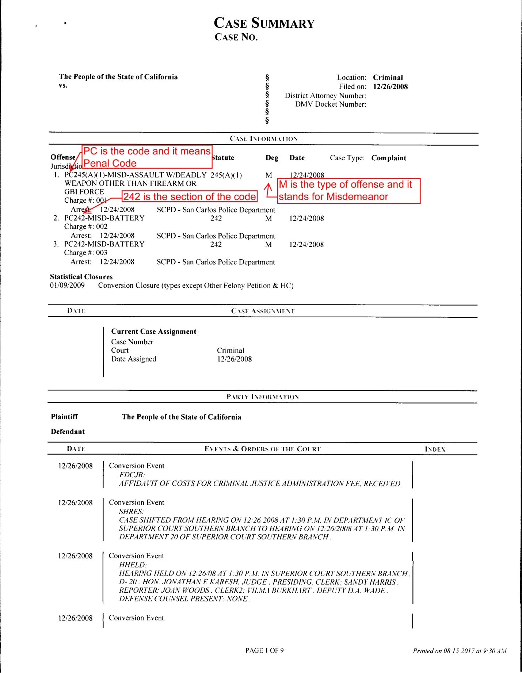
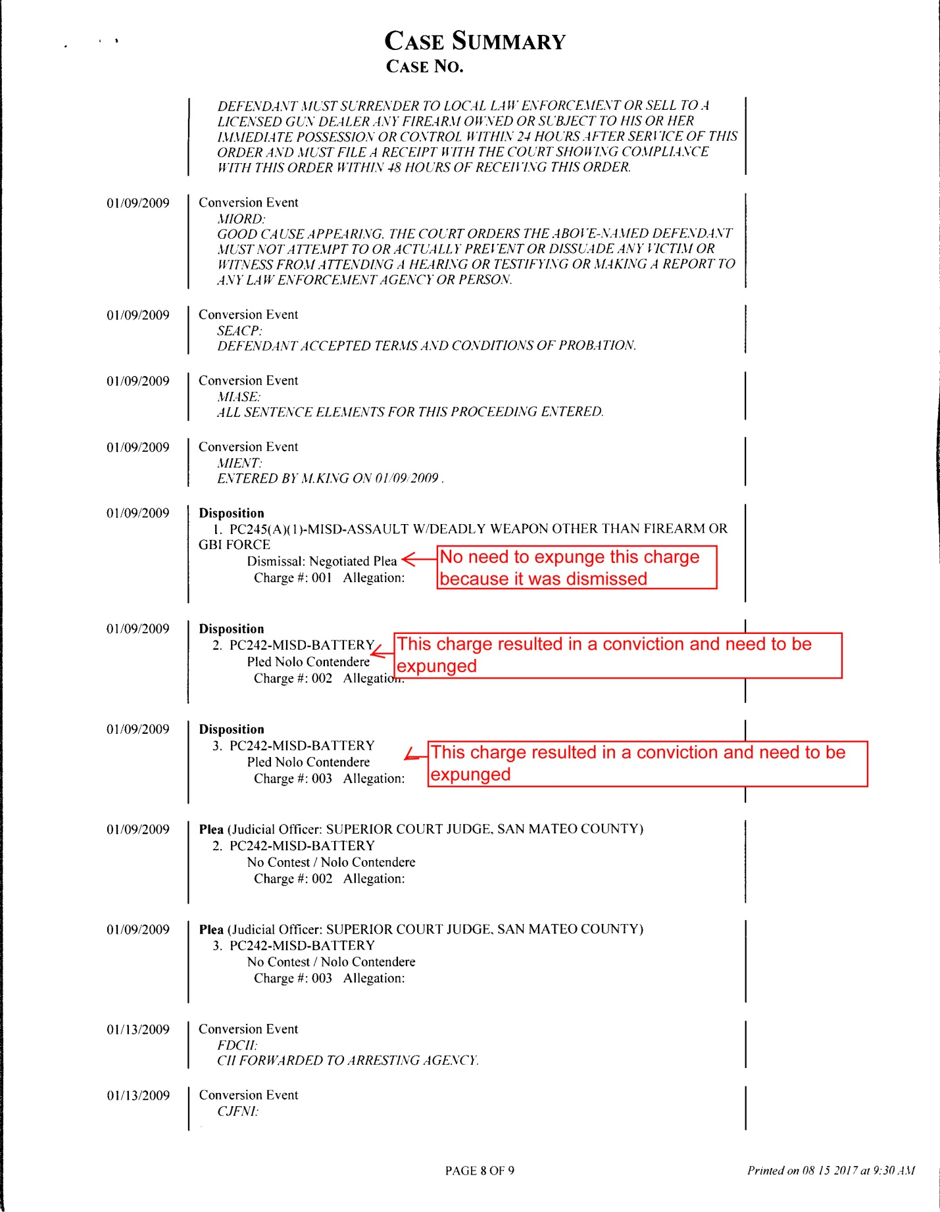

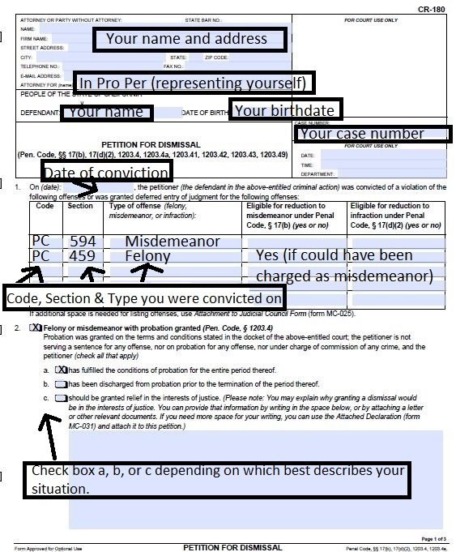

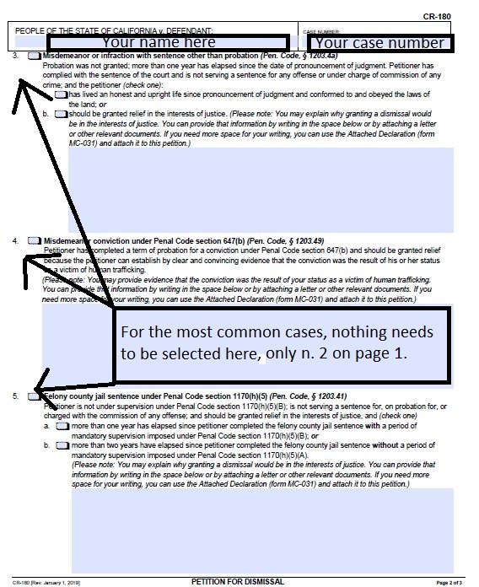

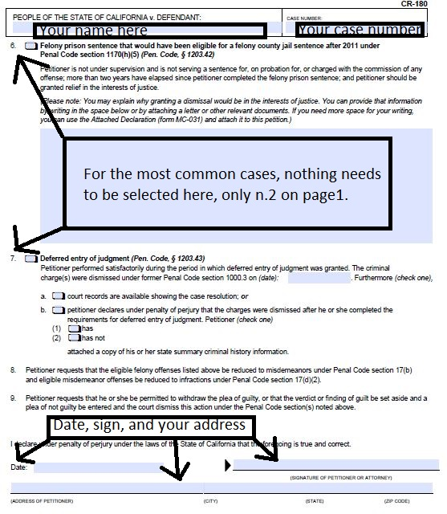
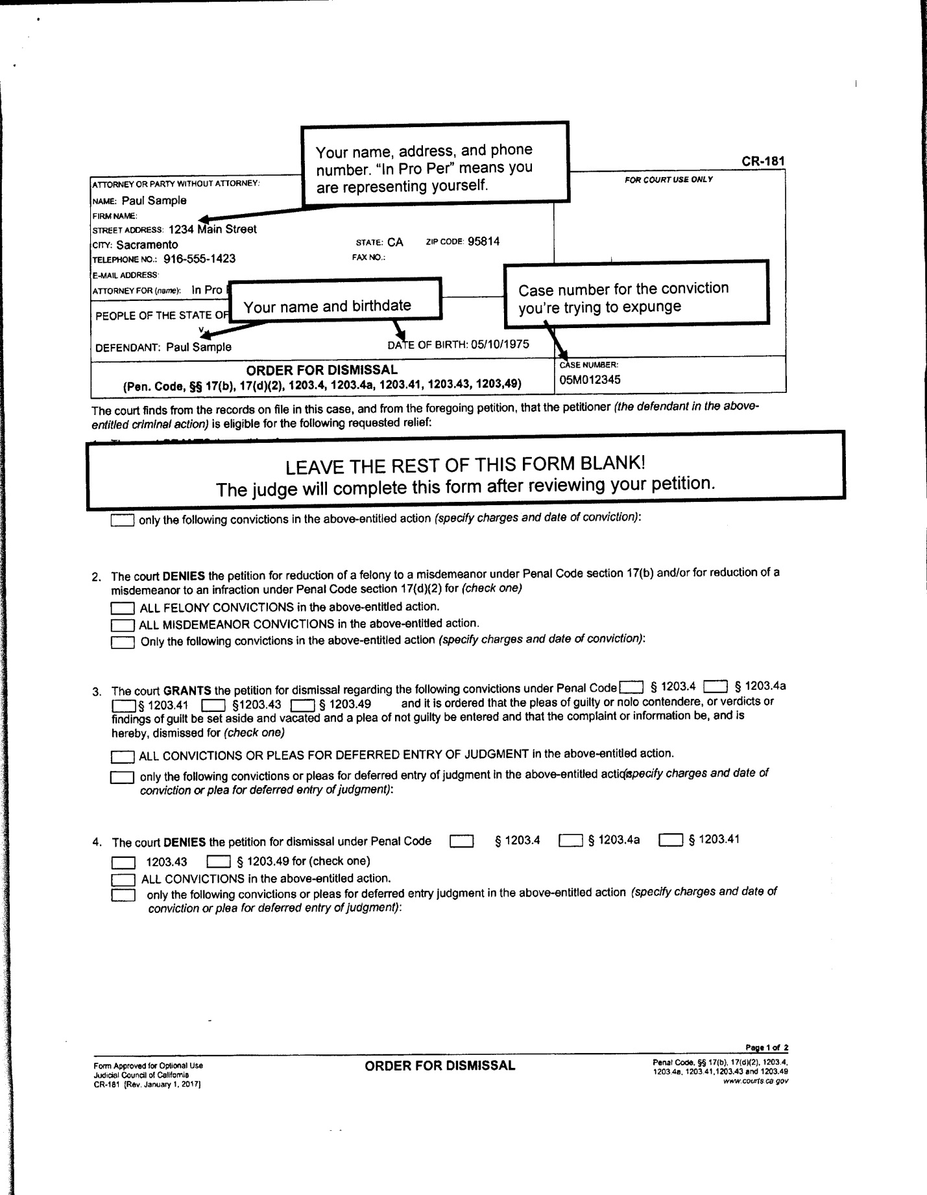

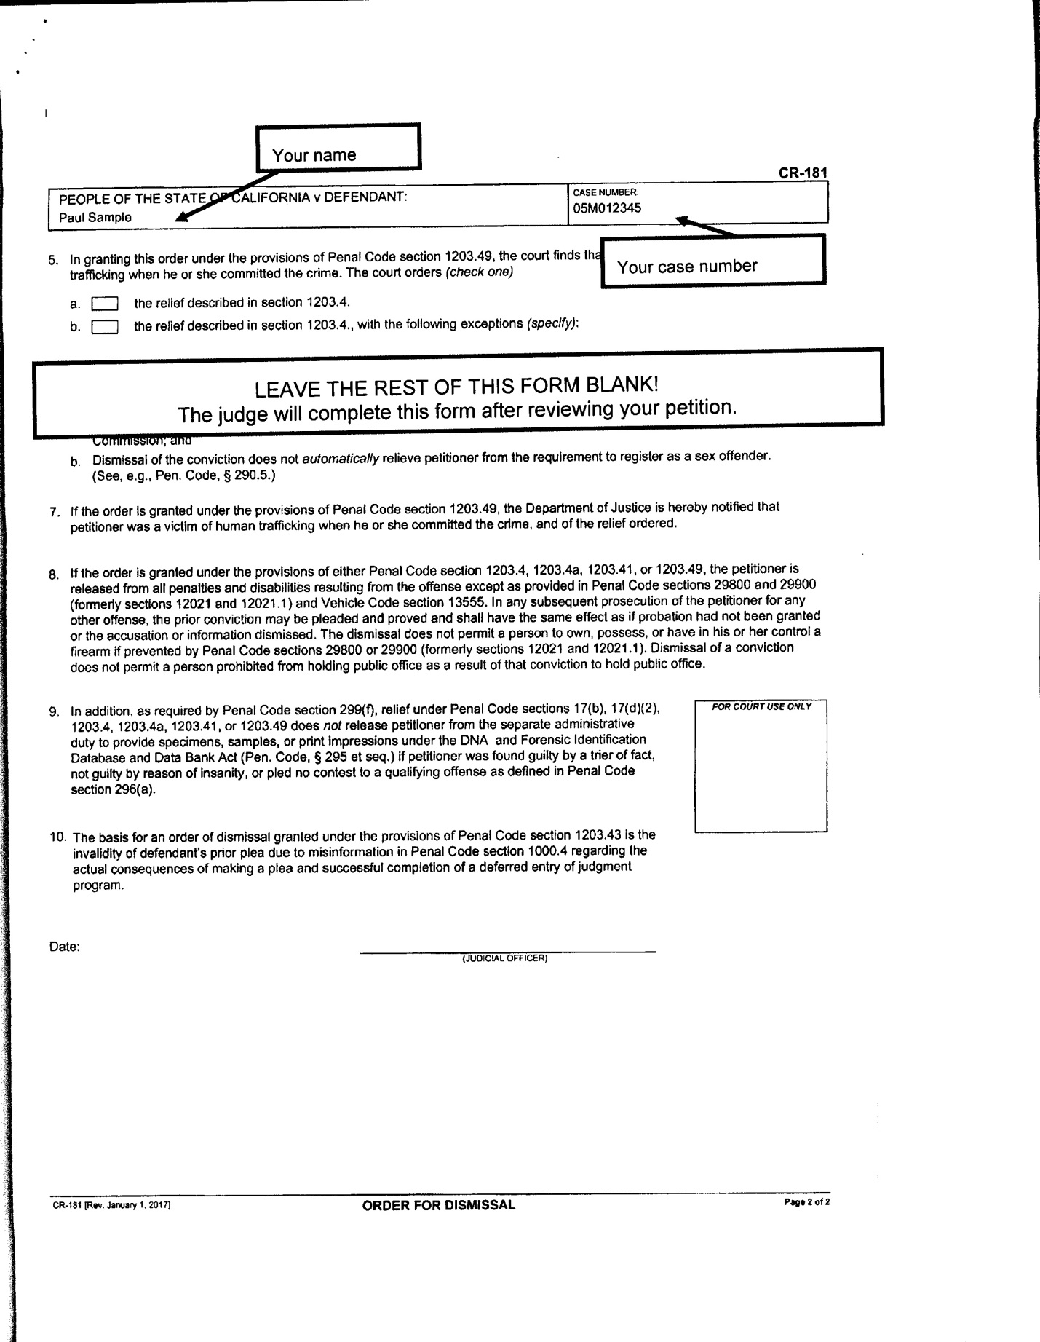

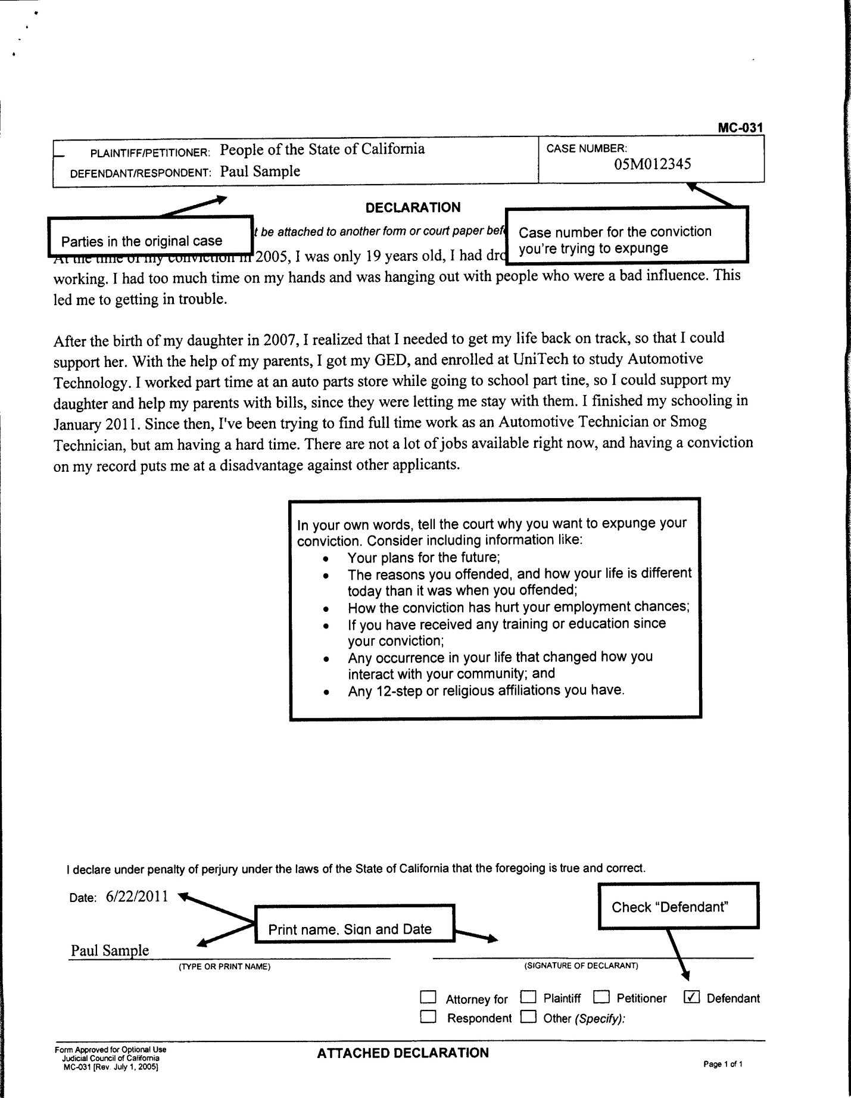
OPTIONAL

