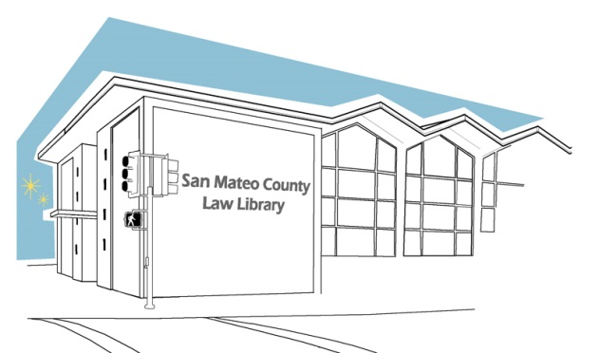
SAN MATEO COUNTY LAW LIBRARY
RESEARCH GUIDE #17

ANSWER CIVIL COMPLAINT FOR PERSONAL INJURY, PROPERTY DAMAGE OR WRONGFUL DEATH ACTIONS
($25,000 OR LESS)

This resource guide only provides guidance, and does not constitute legal advice. If you need legal advice you need to speak with an attorney. To find an attorney to assist you, you may contact the San Mateo County Lawyer Referral Service at (650) 369-4149.

KNOW YOUR OPTIONS?
A lawsuit for money based on a contract, loan or agreement is a civil action. The one who is bringing the lawsuit is called the plaintiff. The one who is being sued is called the defendant. If you are sued, you have several choices:
1. You can defend yourself by filing an Answer to the lawsuit in court. Special forms are used, which you can get from the court. You must file an Answer within 30 days of the date you are personally served with the Summons and Complaint.
2. You can choose to do nothing and allow the plaintiff to obtain a default judgment against you. A default means that you failed to answer the complaint in the time required by law. If a default is entered against you, you CANNOT defend yourself in the case. WARNING: a judgment against you could show on your credit report and result in a wage garnishment or other means of collection.
3. You can try to reach an agreement with the plaintiff. The San Mateo County Superior Court offers Mediation services to assist the parties to resolve their issues with the help of a neutral third party. Mediation is a voluntary process in which a neutral third party, who is a trained mediator, meets with the parties to assist them in settling their dispute. For further information you may call The Multi-Option ADR Project 400 County Center, Redwood City, CA 94063 at (650) 261-5075 or (650) 261-5076.
IMPORTANT: If you wish to explore this option it is advisable that you request an extension of time to answer the complaint confirmed in writing by the Plaintiff or attorney for the Plaintiff or file an Answer to prevent a default being taken against you.

WHAT TO DO:
NOTE: These instructions are for the most common cases, if you have a unique situation, we advise you to talk with an attorney.

STEP 1: Review the Summons

One of the papers you should have received is called a Summons. If you choose to respond to the summons and complaint you must do so within 30 days of the date you were personally served. The 30 days includes Saturdays and Sundays. Do not count the day you were given the lawsuit, but begin counting with the next day. If the 30th day falls on a Saturday or Sunday, you can file the Answer on the following Monday.
To respond you must file a formal paper with the court. The paper is called the Answer. You cannot call the Clerk’s office to get extra time to file an answer in a civil case. Only the plaintiff or the plaintiff’s attorney can give you extra time (called an extension). If you are given an extension, you should confirm it in writing in a letter to the plaintiff or the plaintiff’s attorney and keep a copy of the confirming letter.

STEP 2: Review Your Insurance Polices
It is possible that the lawsuit is covered by your auto, renter’s, homeowner’s or other type of insurance. Take out your policy and review it. Your insurance company may cover your defense in some types of cases.
If your insurance company will cover your defense, make sure to deliver a copy of the Summons and Complaint to the insurance company immediately. Get a receipt from your insurance agent for delivering the lawsuit paperwork.

STEP 3: Complete the Required Forms
You can get the Answer forms online. See the samples at the end of this guide. There is a filing fee due at the time of filing the Answer.
The Judicial Council forms used in this procedure are:
- Answer-Personal Injury, Property Damage, Wrongful Death (PLD-PI-003)

- Proof of Service (POS-030)

- Attachment 6 – Affirmative Defenses (Motor Vehicle)

Step 4: Serving the answer

Before you file your answer with the Clerk, a copy must be served on the Plaintiff or Plaintiff’s attorney. It can be served by mail but must be done by a person who is not a plaintiff or defendant in this case.

Make two copies of the Answer, any attachments and the Proof of Service by mail. One copy is for the server to mail. Take the original and one copy to the clerk for filing.

STEP 5: File your forms
For the San Mateo County, these are filed at the Hall of Justice located at 400 County Center Redwood City, CA 94063 on the 1st Floor. Fee waivers are available for low-income petitioners.

